Lab 2. AWS Storage Service (S3).

2.1-🡪 Create a S3 bucket and Host a standalone HTML web site in S3 bucket which is public access and browse on internet).

Sol.

Step 1: Select the options from Services i.e. Services🡪Storage🡪S3.

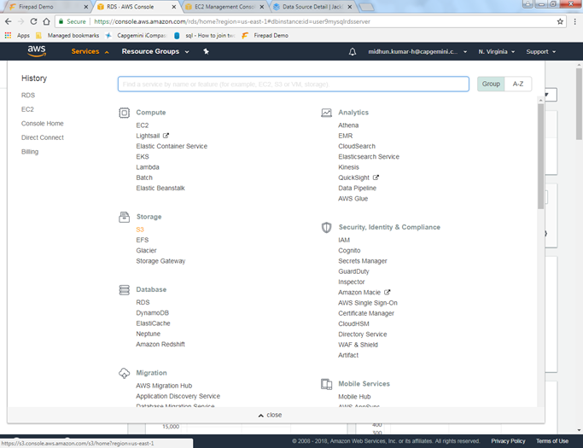

Step 2: In S3, you need to create a Bucket so press Create bucket.

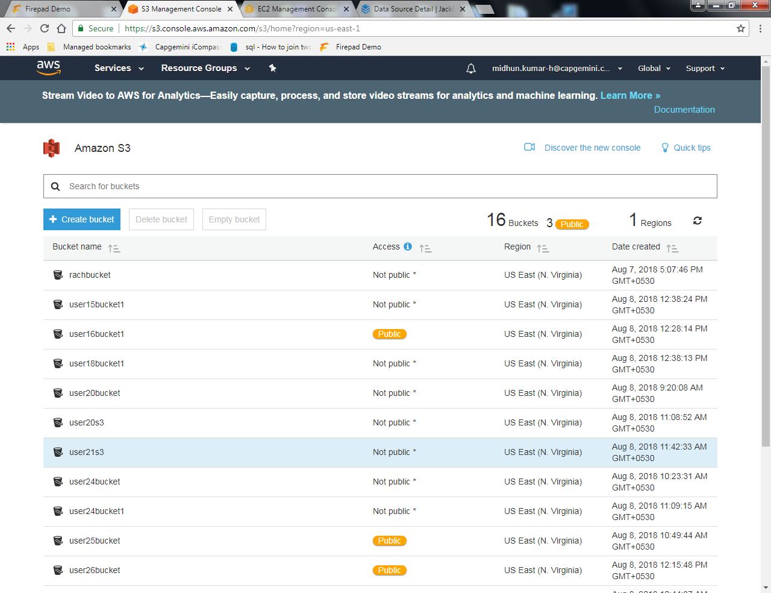

Step 3: Provide the bucket name like the one provided below and click on Next.

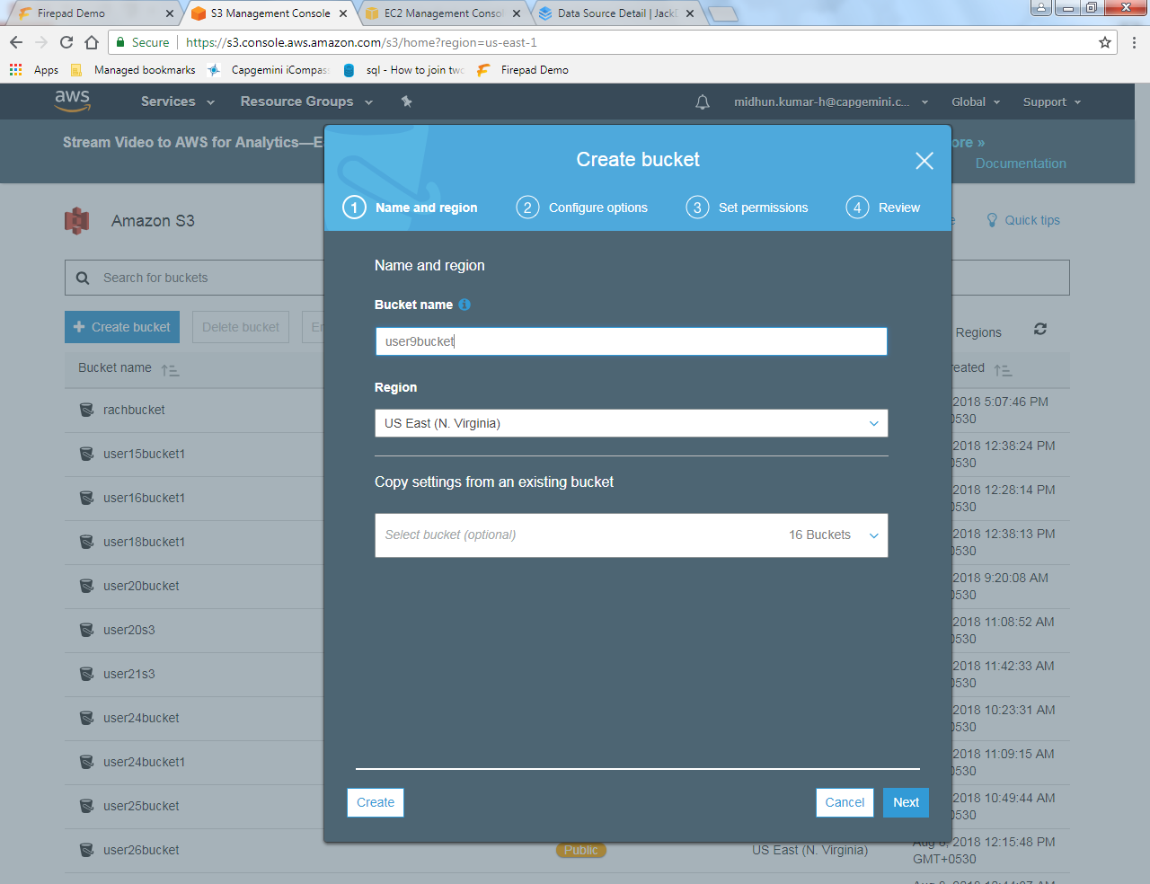

Add Respective Tags and Value to your S3 Bucket.

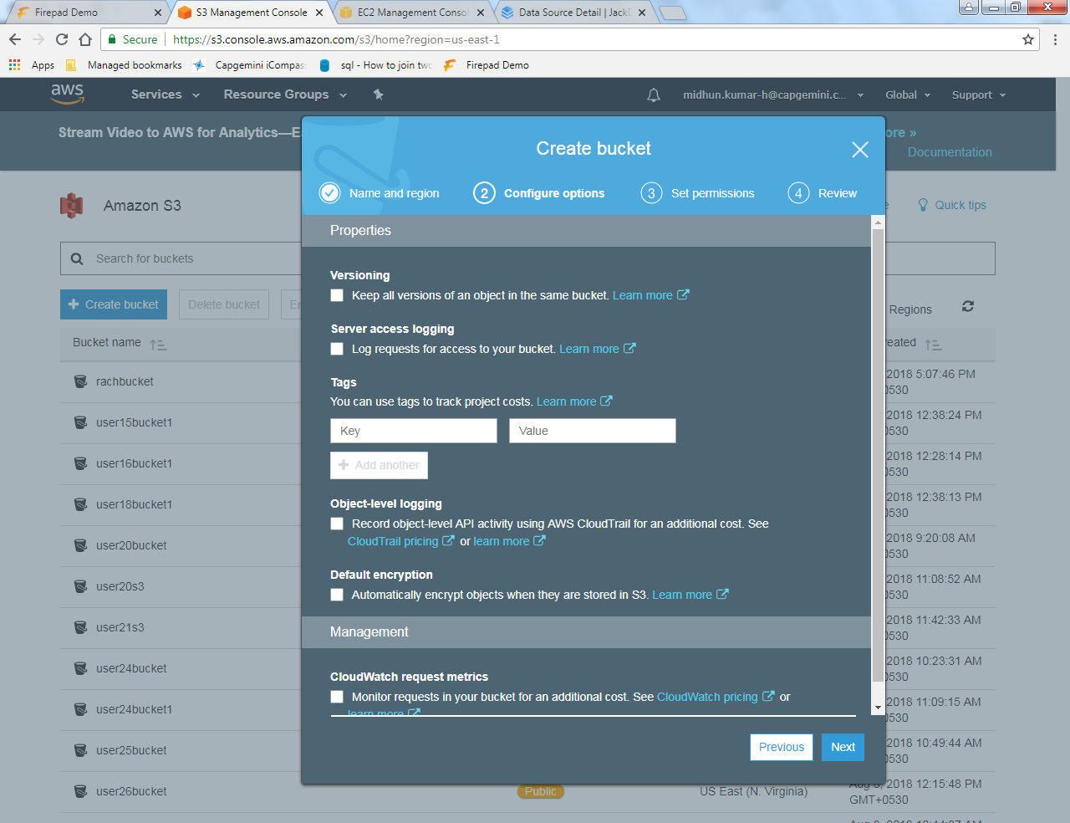

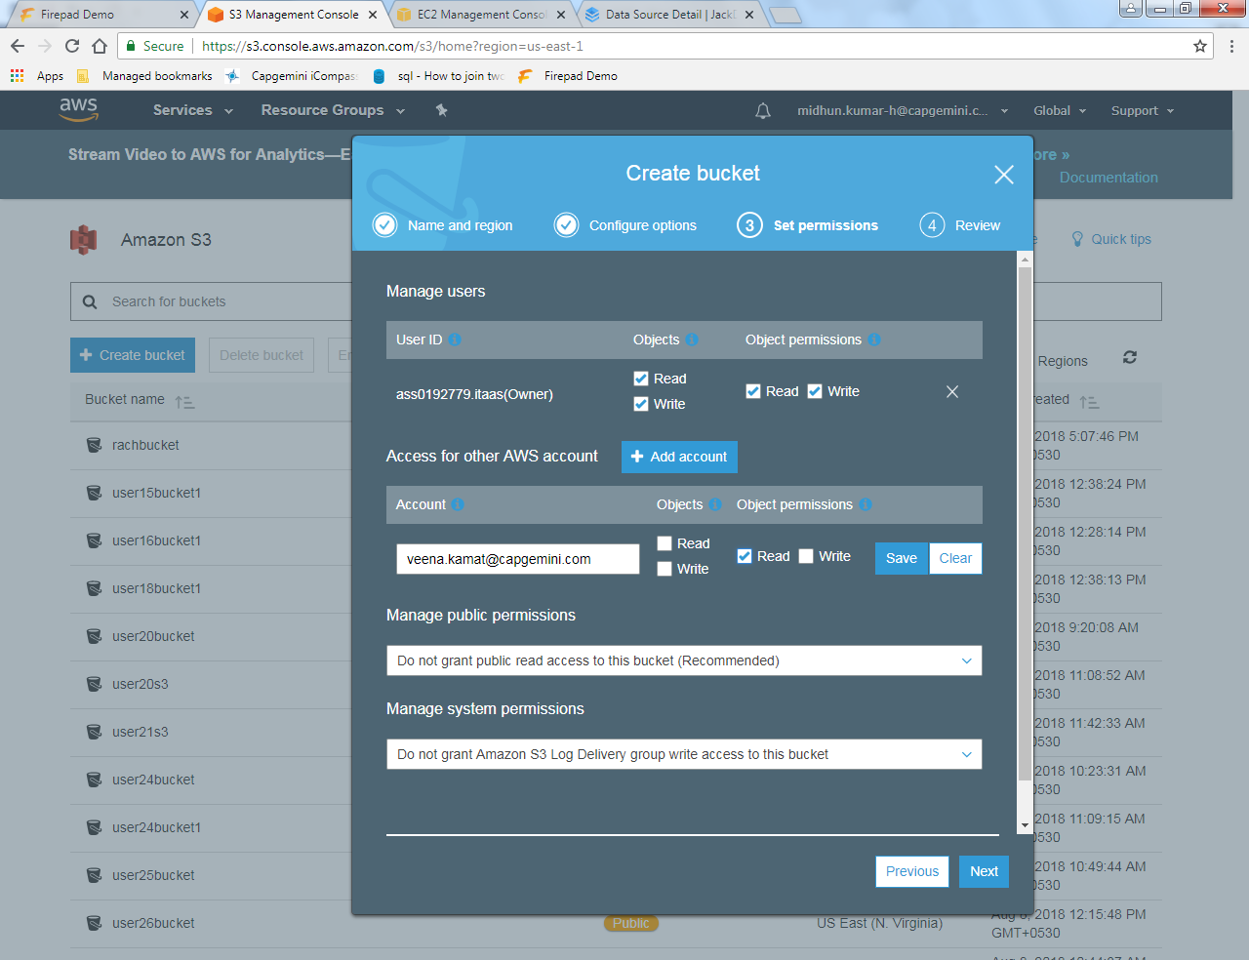

Step 4: In the Set permissions panel, you can add an account of the person you want to include and give him the permissions to read and write.

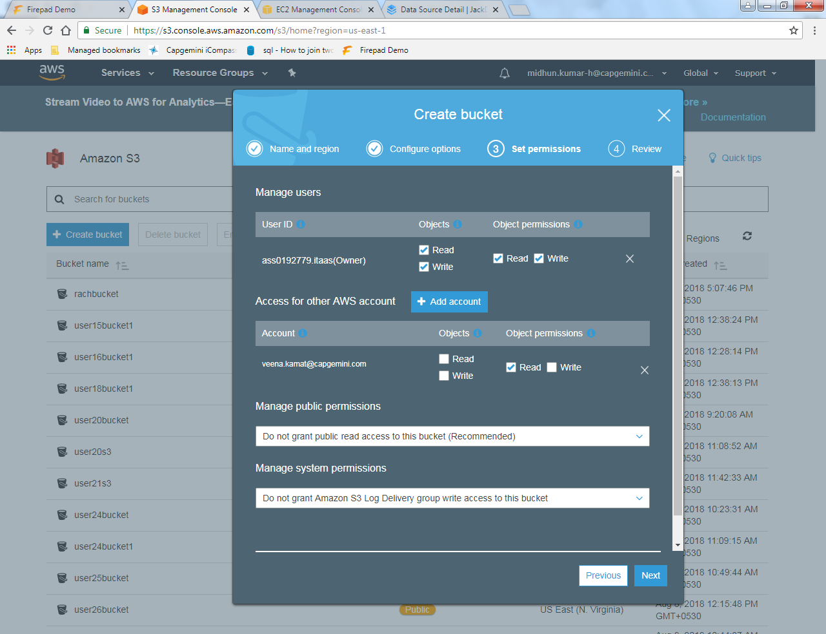

Step 5: On clicking create bucket, you will get a notification that a bucket has been created

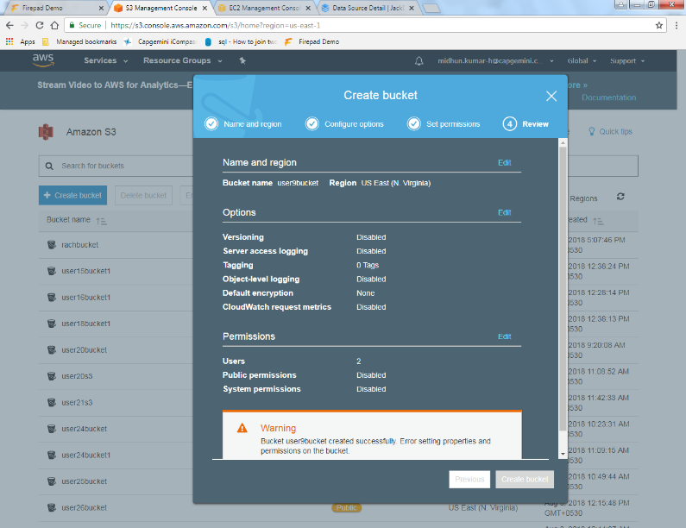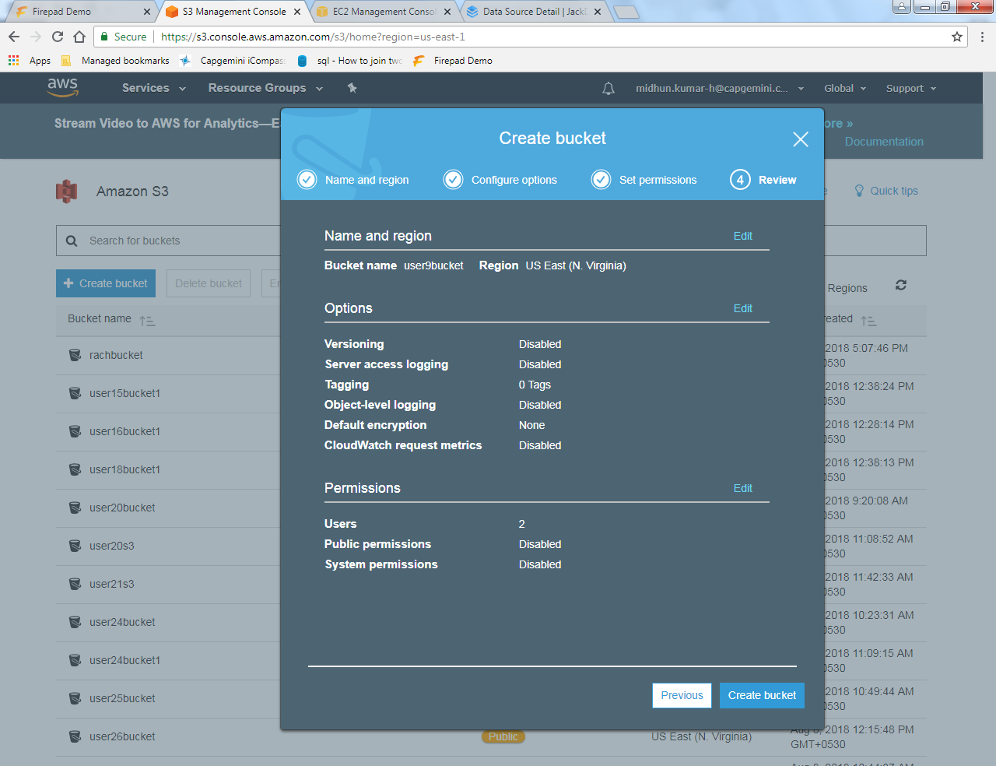

Step 6: You will find your created bucket in the list.

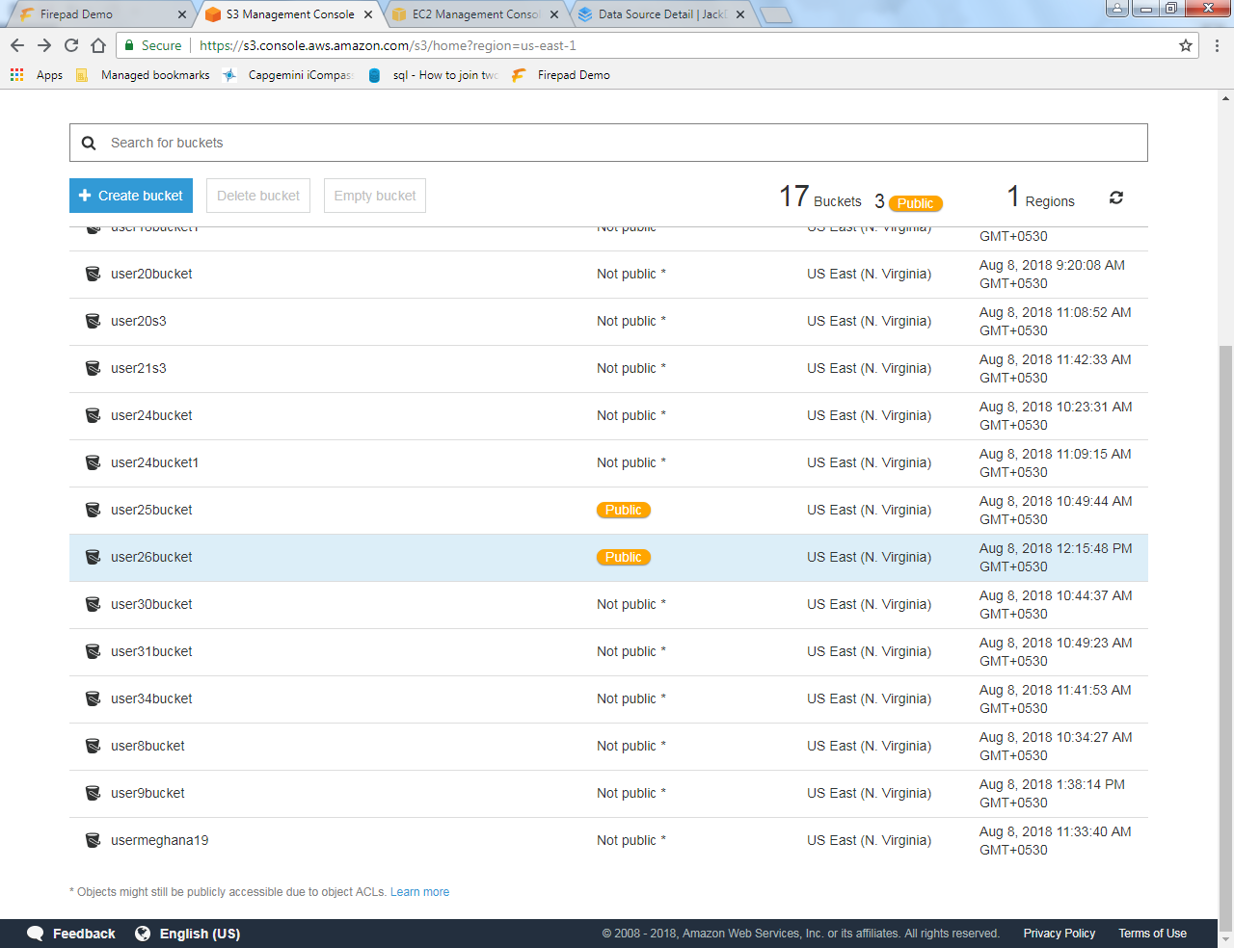

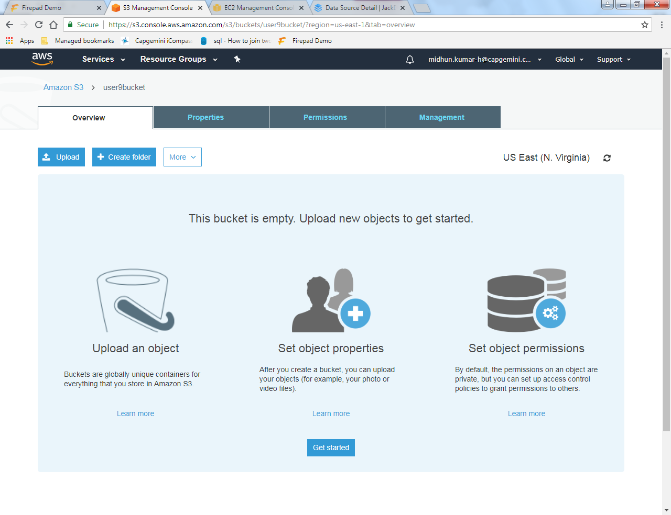

Step 7: On clicking your bucket, you get a page where we can upload the HTML page you created.

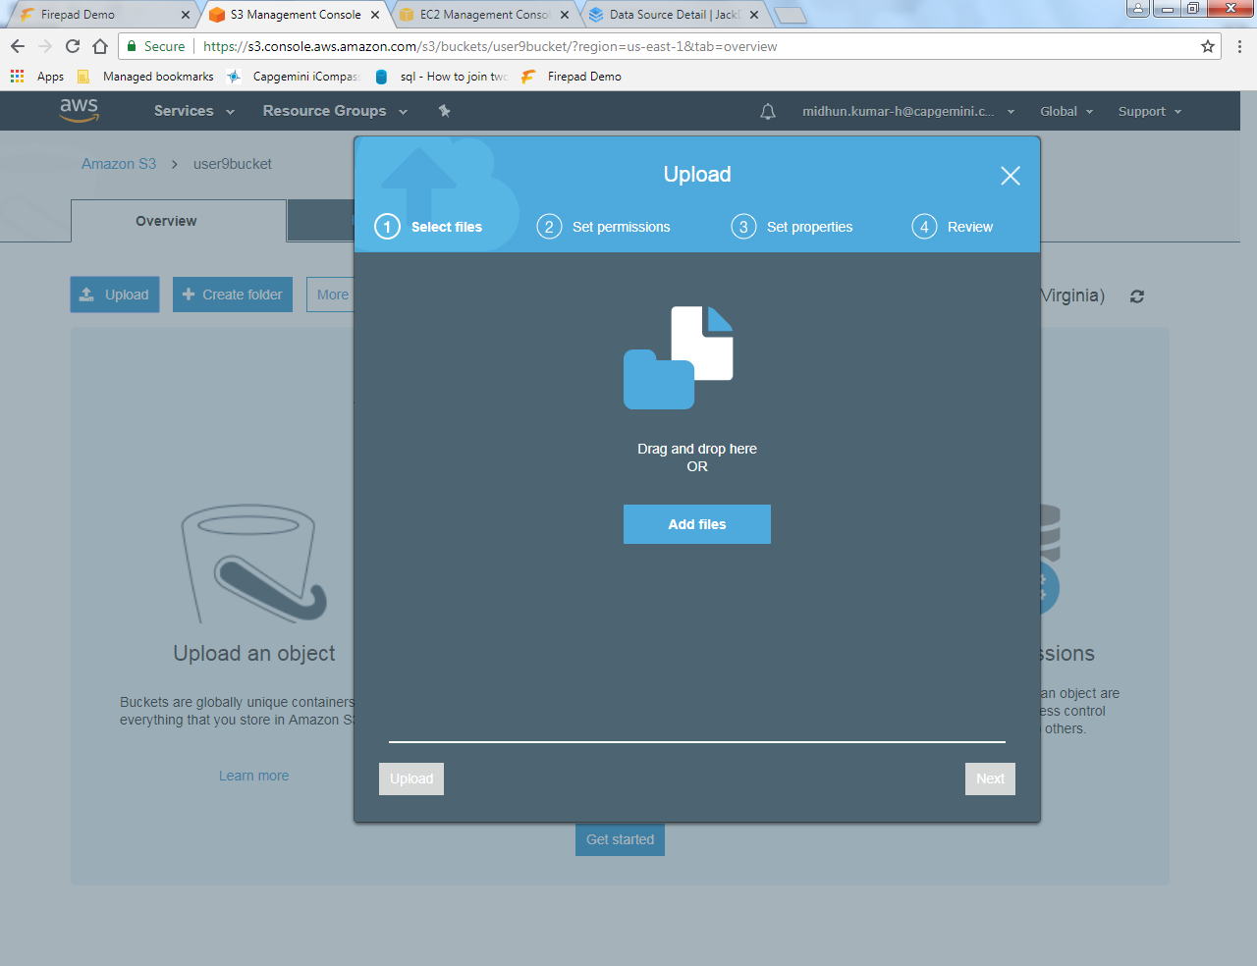

Step 8: Add the HTML page using Add file and Upload it.

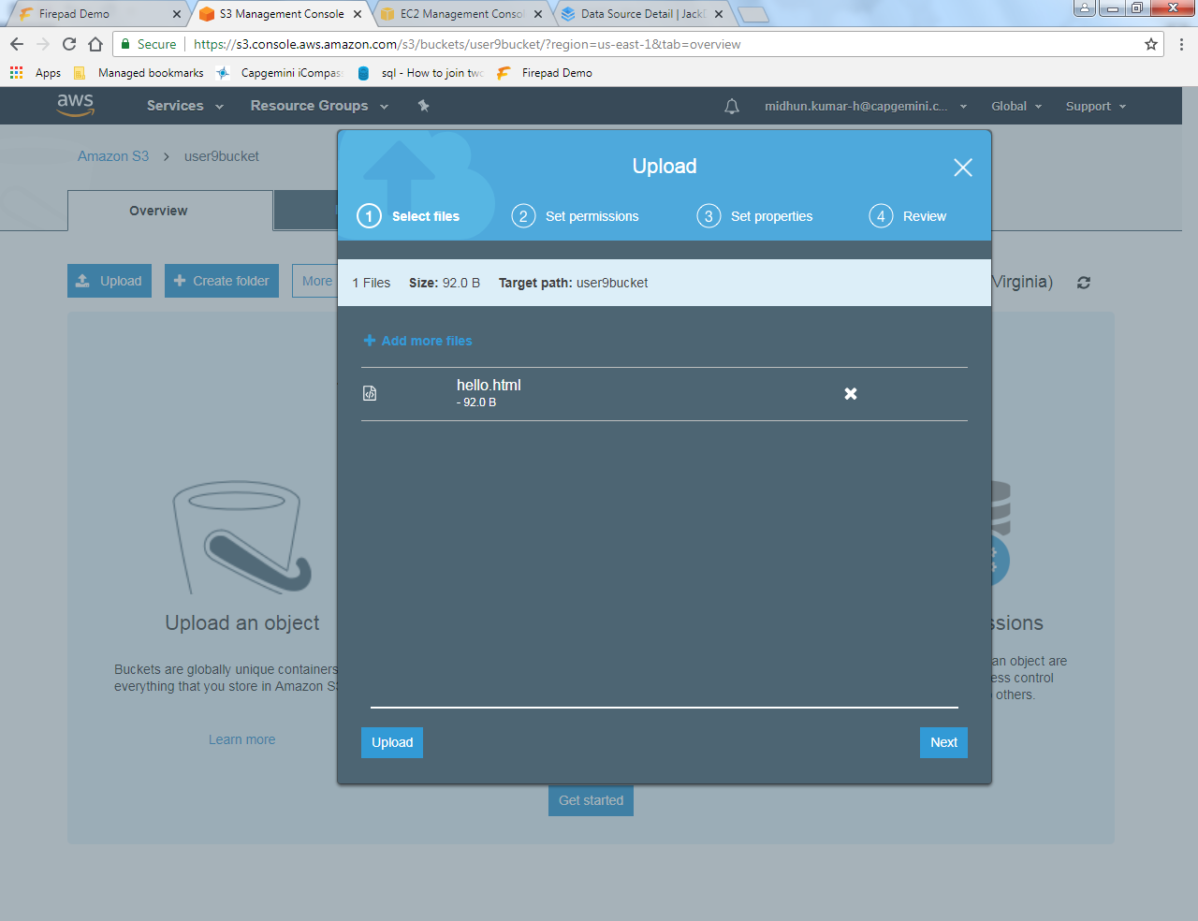

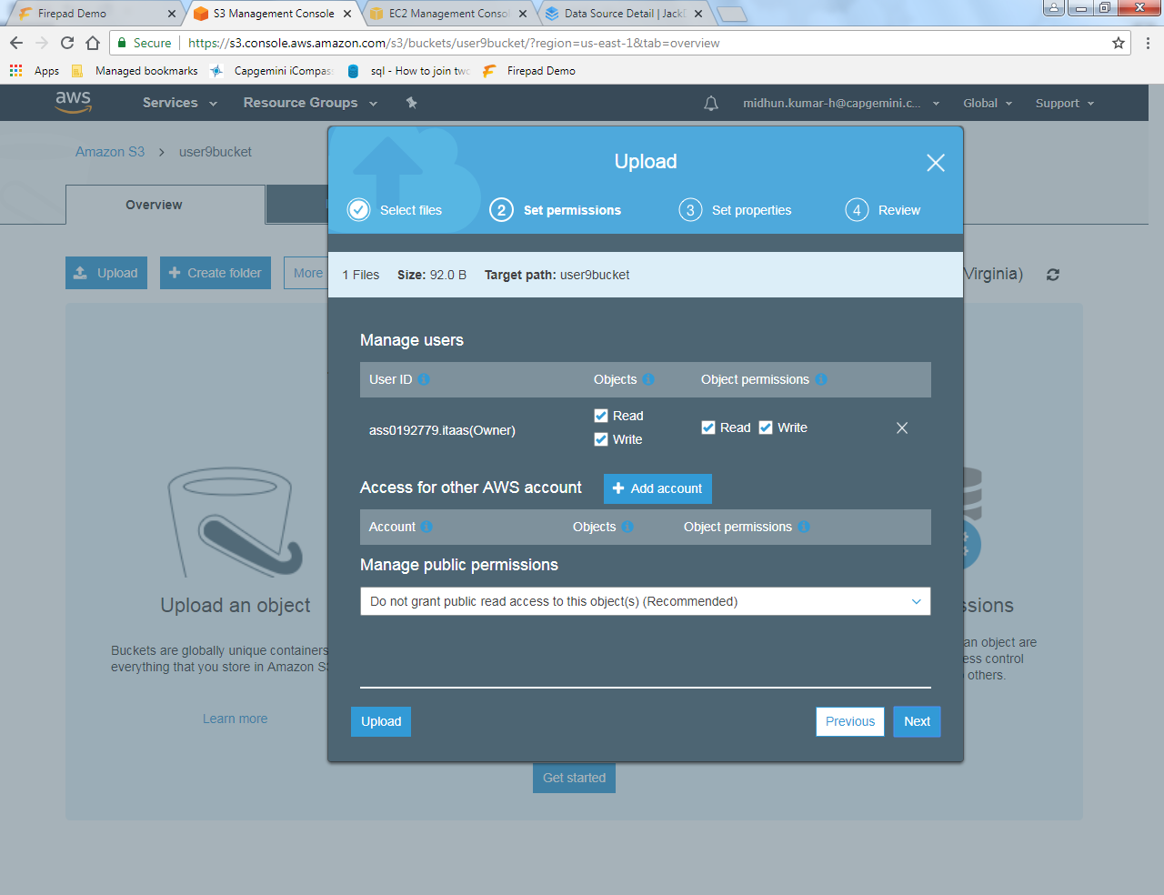

Step 9: Now go to the Properties and select the static website hosting.

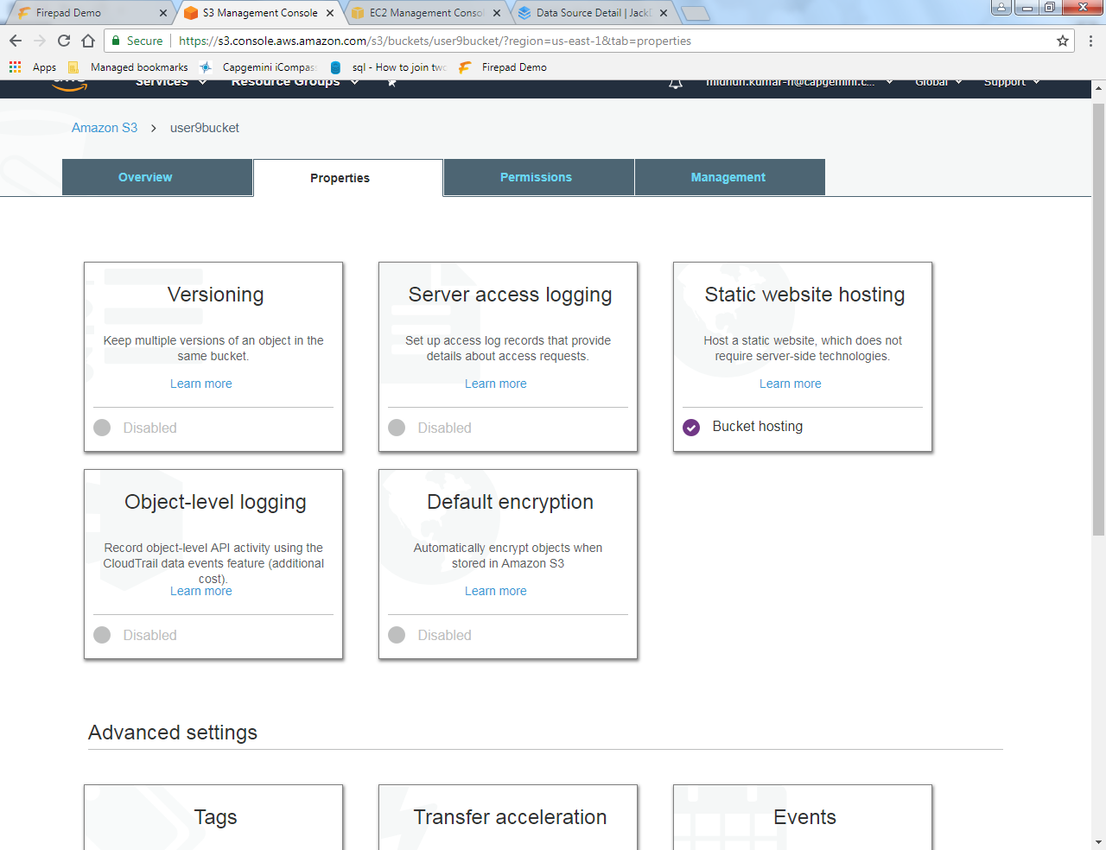

Step 10: In the index document, type the name of the .html file.

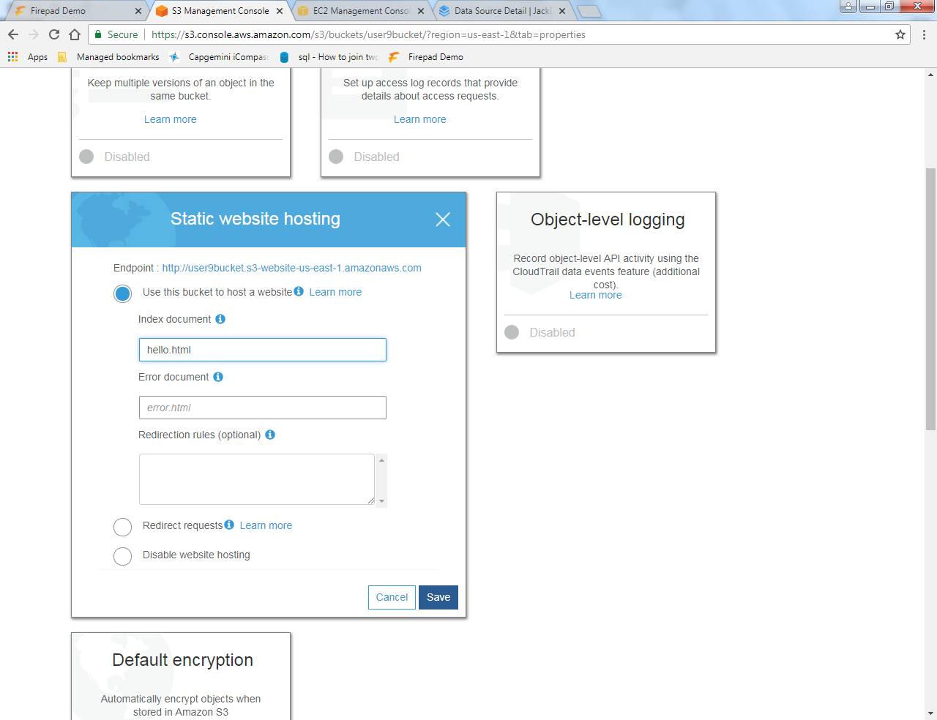

Step 11: After saving, go back to the Overview and click on the HTML file.

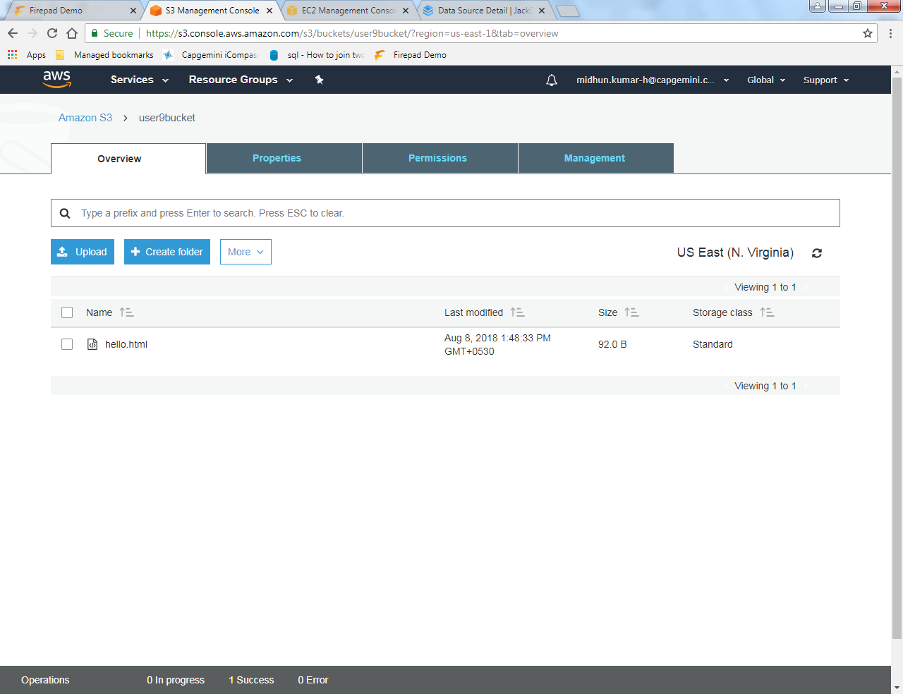

Step 12: On Clicking, we get the details of the html file with a particular link.

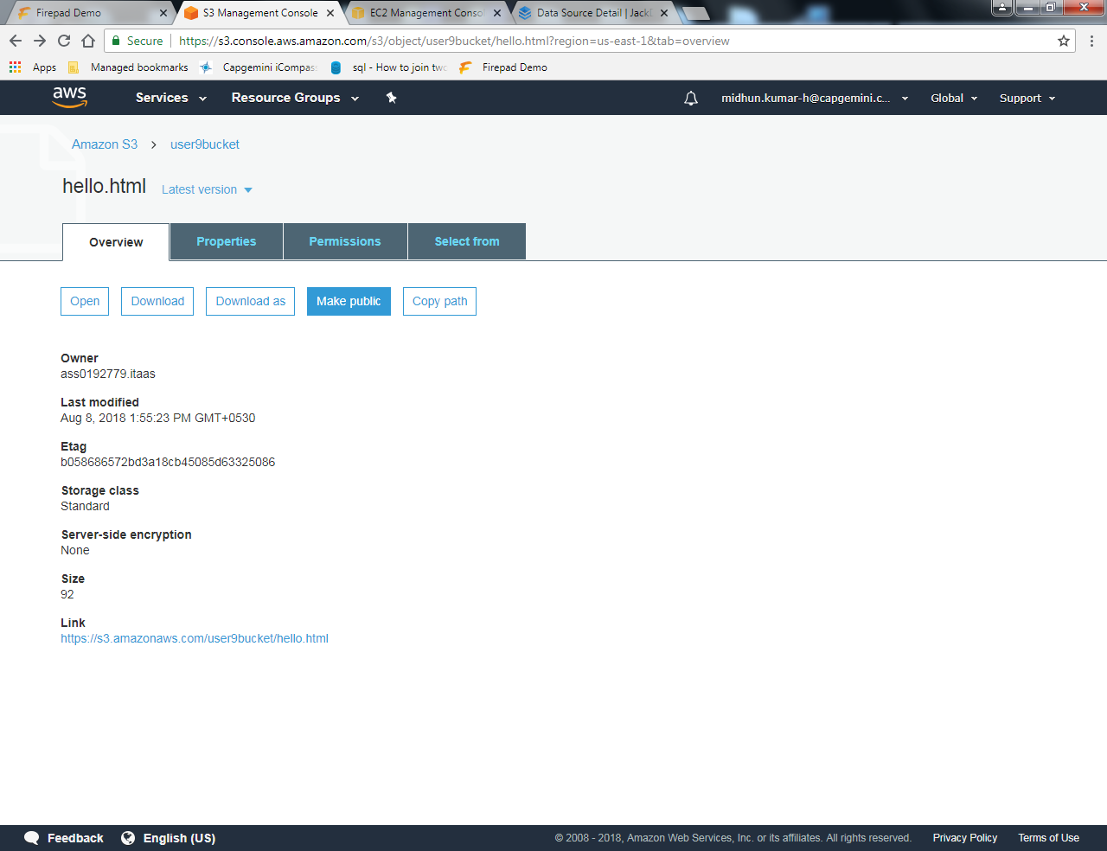

Step 13: On clicking the link, we get the output of the html file as shown below.



\*\*\*\*\*\*\*\*\*\*\*\*\*\*\*\*\*\*\*\*\*\*\*\*\*\*\*\*\*\*\*\*\*\*\*\*\*\*\*\*\*\*The END\*\*\*\*\*\*\*\*\*\*\*\*\*\*\*\*\*\*\*\*\*\*\*\*\*\*\*\*\*\*\*\*\*\*\*\*\*\*\*\*